A group of more than 10 intrepid guides were joining our fabulous famil fairy Sharron Hickman and her sidekick Anja Gallas on Friday, August 1 to explore the hidden wonders around Auckland’s K’Road and surroundings. Under the motto ‘I DID NOT KNOW THAT WAS THERE’ we learned a lot about local fashion, design and tattoos studios as well as the hospitality scene. At the end, we were rewarded with beautiful views of Auckland’s CBD from the popular rooftop bar. All destinations are suited to take overseas visitors, large and small groups, for a visit.
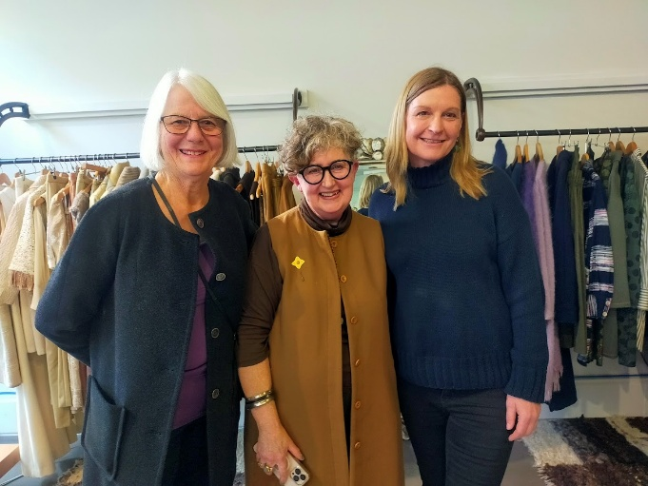
First up was a visit at one of New Zealand’s top fashion designers, Liz Mitchell. She is an ambassador for the Campaign for Wool Movement, a global organisation headed by King Charles III. She showed us her marvellous bespoke couture. A lot of her products were made of exquisite wool. She knows the story behind farmers, spinners, makers and suppliers. Liz and her team are creating the collections out of her Auckland workshops, one is based in Henderson, for more than 30 years.
Liz Mitchell
196 Great North Road,
Grey Lynn, Auckland,
ph 0220432281
https://www.lizmitchell.co.nz

We also met Heather Anderson from Avgar Sport. Heather gave an insight into her professional career, which spans a number of decades, and into her latest venture. In cooperation with Design Director Gwyn Jones, she created a modular golf trundler, Uforia, which is unique, stylish and logical. The invention has gained international patents and trademarks.
Heather Anderson
Auckland 1011, New Zealand
ph 0272734716
https://avgarsport.com/
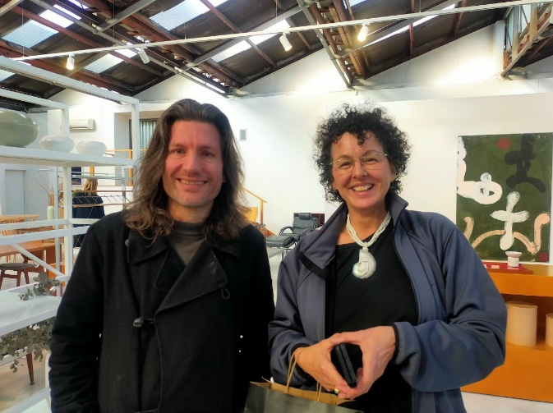
After a short walk across the motorway bridge into Newton, a visit of Good Form was on the itinerary. Dan and Emma Eagle are the founders of the design company. The couple are collecting and offering rare and authentic mid-century furniture and vintage design icons - from Danish and Scandinavian classics through to bold Italian creations. Dan also pointed out, that the company offers a selection of local New Zealand talent, presented comfortably next to some of the best design in the world. Good Form represent and stock artistic floor rugs by Dilana Rugs, Christchurch.
Good Form (formerly Mr Bigglesworthy)  Dan and Emma Eagle  96, Newton Road, Eden Terrace  ph. 021862269  hello@goodform.co.nz  https://www.goodform.co.nz/ | Dilana Rugs  102 Buchan Street  Sydenham, Christchurch 8023  ph. 033665866 and 0800345262  info@dilana.co.nz  https://dilana.co.nz

Back to K’Road again, Lost and Astray was on the itinerary. It’s the store and workshop of designer Sarah-Jane Duff, whose focus is on plus size fashion. Sarah is a fierce advocate for believing in the power of looking and feeling good in oneself, no matter how big the body. She and her small team produce designer plus size clothing that can be mixed and layered in a variety of ways.

Sarah-Jane Duff
Losts and led astray
LaLA Studio & Store
482 Karangahape Road
Auckland 1010
Ph. 02108400570
https://lostandledastray.co.nz

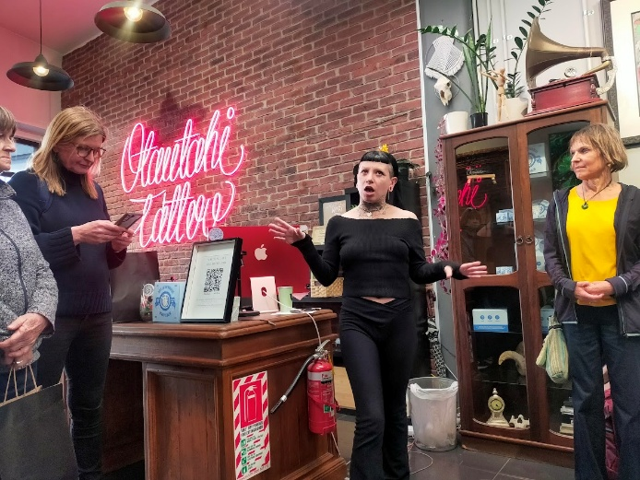
Further along K Road from Sarah-Jane, we entered Otautahi Tattoo Studio and were introduced to the diverse style of tattoos. The crew at the store have been designing and creating above and beyond tattoos for over a decade and are familiar with all sorts of styles. They cover many genres and styles of tattooing, from Maori Ta Moko to Polynesian Tatau as well as classic traditional tattoos.

Otautahi Tattoo
155 Karangahape Road
auckland@otautahitattoo.com
https://otautahitattoo.com/auckland/

After the visit, we left K’Road and ventured through Myers Park to have a look at the Waimahara Art Installation (the singing spirit of water), in the underpass of Mayoral Drive. Commissioned by the Auckland Council, this interactive artwork, created by Maori artist Graham Tipene, features mesmerising light and sound displays. The sound of birds, water and other melodies are triggered by the movement of walking underneath the bridge. It will be a great sight to enjoy, once all the construction work around the place is completed and the art work is easier to find.
https://ourauckland.aucklandcouncil.govt.nz/news/2024/06/waimahara-is-set-to-sing-with-you-in-light-and-sound-a-first-for-public-art/

Late afternoon, it was time to check out the surrounding restaurants and hotels regarding their offer.

Le Garde-Manger
466 Queen Street, Auckland 1010
ph. 09-3620655
https://www.legardemanger.co.nz/
French ambiance in the middle of Auckland city. It is recommended to book a table beforehand, specifically if you are touring with a group.

St. Kevins Arcade
183, Karangahape Road
Auckland 1010
https://www.stkevinsarcade.co.nz/eatdrink
There are several eateries ( Besti, Pici, Lowbrow, Sagrado Cantino, Sal’s Pizza to name a few) in the Arcade, which is like a shopping mall and has another entrance to Myers Park.

Eight Restaurant
Cordis Hotel
83, Symonds Street
Grafton, Auckland 1010
ph 09 300 2924
https://eightrestaurant.co.nz/
The restaurant offers an interactive dining experience with eight different cooking stations, where you can choose your favourite dishes as often as you like. From freshly rolled sushi, prime cuts, seafood, Indian curries to delicious deserts. It seats large groups and is open for breakfast, lunch and dinner.

Last stop and final destination was the rooftop bar at the Sheraton Hotel at the upper end of Queen Street.

The Churchill Auckland
396 Queen Street
Auckland 1010
ph 09 393 8240
info@thechurchillauckland.co.nz
https://www.thechurchillauckland.co.nz/

The Churchill is one of Auckland’s premier luxury rooftop bars, located on the 20th floor of the Four Points by Sheraton Hotel. With breathtaking panoramic views of the city, we finished our famil extraordinaire. It was a refreshing and interesting tour with lots of sites to see that were formerly not known to us.



For great historical information to do with K Road become a Facebook friend of this Facebook page - K Road Heritage

Many thanks to our two excellent leaders Sharron and Anja. We are looking forward to our next trip. Feel free to contact ProGuides with famil ideas.

