Wellington Famil 28 August 2025

Stansborough Mill – 70 Fitzherbert Street, Petone. P: +64 4 566 5591 Contact: Cheryl Eldridge – P: +64 21 773 519 www.stansborough.co.nz
The Stansborough Grey sheep originates from Gotland Island, Denmark. 3000-acre farm with 1500 sheep and 1000 cattle. Farm between Martinborough & Castle Point, very remote so Farm Tours not an option. Shop and factory tours are available. See website for details or ring Cheryl to arrange a tour to suit.
Wool produced is a strong fibre, best used for outer layers, scarves. The top selling product made are capes as worn by Gandalf and Frodo. Stansborough work closely with Weta Caves, Hobbiton, hotels, luxury lodges etc.
Products are 100% NZ made. All wool is weaved at the Petone premises.
6 looms, 2 of which date back to 1800’s.
Great visit for the tour or to look/buy woollen products. The history is unique & entertaining. It starts by going through a wardrobe which brings back memories of Narnia… After the tour, consider a coffee stop on Jackson Street, Petone a bohemian shopping strip with old historic buildings.

Suzanne Aubert Heritage Centre - 2 Rhine Street, Island Bay. Contact Jo White. jo.white@compassion.org.nz
P: 04 282 1953 E: islandbay@compassion.org.nz www.compassion.org.nz
Suzanne Aubert, born 1835 in France, left France to avoid marrying the boy next door as planned by her parents. Sailed on a whaling ship to NZ with Bishop Pompallier, taught herself Te Reo, was also name Meri Hōhepa.
Daughters of our Lady of Compassion – took in unwanted babies. Is in Jerusalem, Whanganui.
Died 1 Oct 1926. She is interred in the chapel. When she died, the funeral was the largest any woman had had in New Zealand.
A sainthood is in progress.
Entry is free of charge.
Guided tours available on request, but complex is open to visitors. Contact Jo White. jo.white@compassion.org.nz
Mass 8.30am weekdays.
Two museums, one dedicated to Suzanne Aubert, the other a timeline and documentation of the work of the Sisters of Compassion.
Chapel with stained glass windows designed by John Drawbridge.
Retreats with accommodation available, meeting rooms etc.
Cloister Café on site.

Wanderlust Tours - Marc Landrain - P : 021 130 9014 – E : landrainmarc@yahoo.com
Marc Landrain – an excellent guide with a fascinating story about how he became a LOTR guide. Sailed solo without any form of communications from France arriving in Tahiti. Swapped his only book for LOTR book which he read on his way to New Zealand… Wanderlust run half day and full day LOTR tours (include filming sights and Weta Workshop tour) and Seal Coast Safari tours.

Weta Workshop – corner Camperdown Road & Weka Street, Mirama. P: 04 909 4035
E: info@wetaworkshop.co.nz www.wetaworkshop.com
Tour takes you through various stages of how different effects are made along with some history of Peter Jackson started filming, how the Weta Workshop began. This is where the models were made for Gallipoli Exhibition. Also various creatures & models made for films like The Amazing Spiderman 2, Power Rangers, Elysium.
See a 3D printer at work
Visit Model Alley – where models are made from recycled and repurposed everyday materials.
Weta Workshop had an average employee age of 22.

Space Place – at the top of the Cable Car www.museumswellington.org.nz/space-place
Houses the Thomas Cook telescope – 158 years old, was shipped to Napier in the 1920’s. It took a picture of Haley’s Comet. The roof opens up with views to the Milky Way, which is difficult to see in the Northern Hemisphere due to light pollution
There is a book collection owned by Leslie John Comrie who was an astronomer. When the war broke out, he dad his books shipped to NZ to prevent them from being destroyed during the Blitz.
There are pillars filled with 1 billion grains of sand to demonstrate the size of the galaxy which has 100-400 billion stars.

Wellington to Palmerston North Famil 29 August 2025

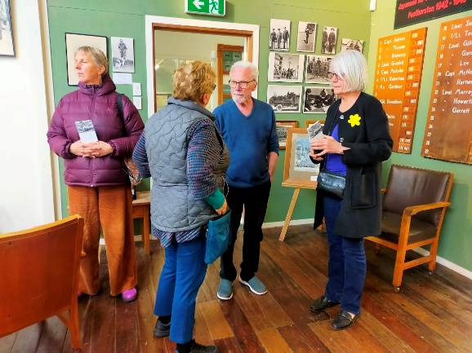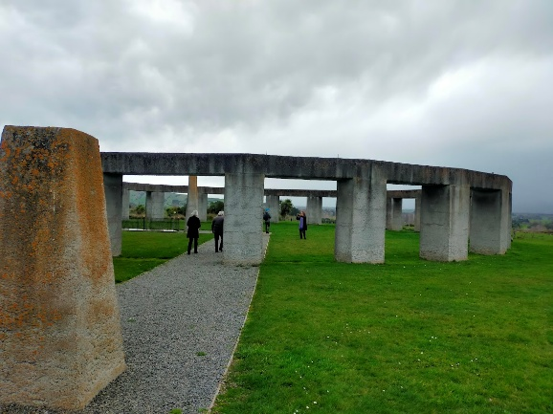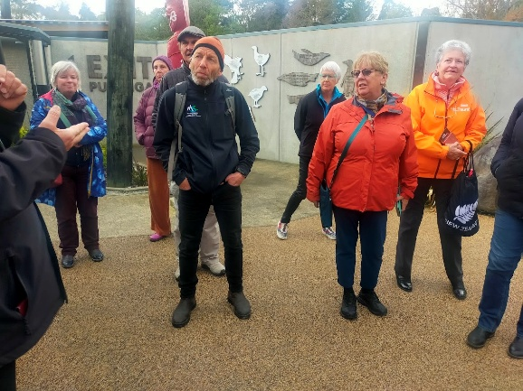

Featherston Museum (not Fell Locomotive Museum which is next door) – 70-72 Fitzherbert Street. P: 027 389 1803 featherstonheritage@gmail.com featherstonheritagemuseum.com
Featherston Museum has displays and stories relating to the Military Camp built 1916 and which had 60,000 soldiers go through training here. Then they marched over the Rimutaka Hills to be shipped off to war.
WWII it became a Military prison. Japanese soldiers captured in Solomon Islands were sent here. They made artworks as gifts for their guards. These items are now on display. Featherston Camp and memorials and Japanese Memorial Garden can be found 2.4 kilometres east of Featherston on State Highway 2. There are 49 flowering cherry trees planted for the 48 Japanese & 1 NZ soldier that were killed during the February 1943 ‘incident’.

Greytown
2 new bus stops opened at northern end of town, close to Kokodeli Cafe – one each side of the road.
Kokodeli Café – opens out on to a courtyard, 74 Main Street, P: 06 304 7159 Call and speak to Xavier to make bookings.
Great food and great service.
On the corner of the courtyard is a great second-hand clothing shop.

Stonehenge Aotearoa – 51 Ahiaruhe Road, RD2, Carterton, P: 027 230 5190 contact@stonehenge-aotearoa.nz stonehenge-aotearoa.nz
Not a replica but purpose built. Used concrete as the stones were mostly shattered during the earthquake. Starting points of civilisation as we know it. Great acoustics in the middle.
Star Trek – night visit by arrangement - Wairarapa deemed a ‘dark sky’.

Norsewood,
Although we didn’t have time to visit Norsewood, we thought that everyone would like to know the following information:
Split by State Highway 2 (east side of State Highway 2) feed the eels (they love dog biscuits) at Wopwops Wetlands, 75-79 Hovding Street (on east side of village), Norsewood.
Café Norsewood, Coronation Street (west side State Highway 2), Norsewood, seats 30. Ring Vivian P: 06 374 0749 Further information can be found at Café Norsewood on Facebook. No toilets in café. There are 3 toilets next door in the Norsewood Community Hall.

Central Energy Trust Wildbase Recovery – 20 Victoria Drive, West End, Palmerston North
www.wildbaserecovery.co.nz info@wildbaserecovery.co.nz
Specialised wildlife rehabilitation and conservation education centre. Free entry, guided tours $10 per person, open 7 days, 10 am to 4 pm. Run by 80-90 volunteers.

Palmerston North Famil 31 August 2025

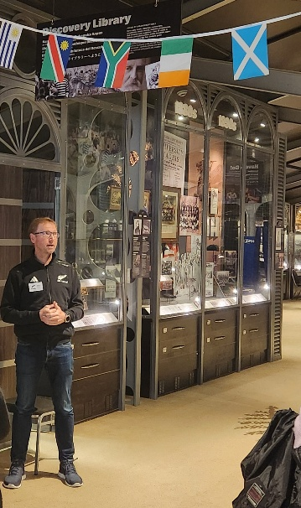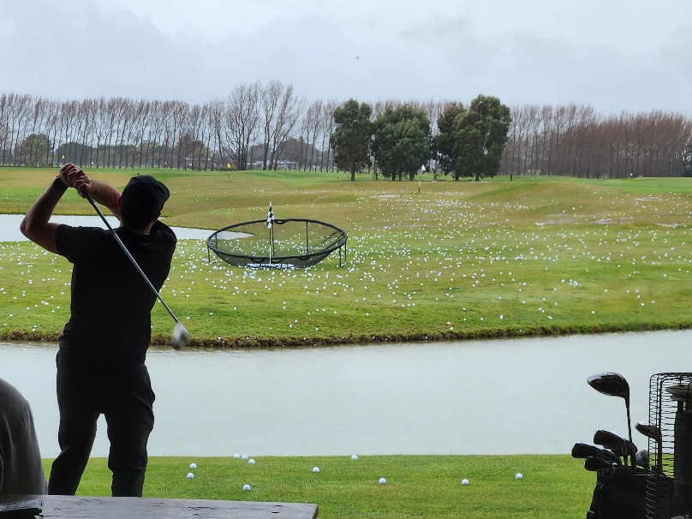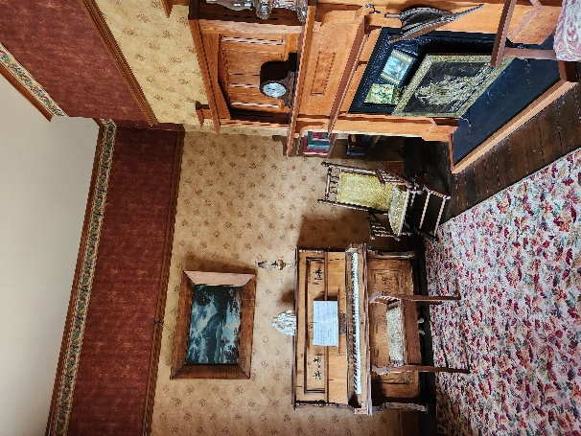

Regent Theatre – 53 Broadway Avenue. Opened 4th July 1930. Art Deco style. Guided tours by arrangement. www.regent.co.nz P: 06 350 2100
Massey University – Tennent Drive, Palmerston North. Drive through grounds, large and parklike. Only veterinarian school here. 27000 students, 3000 staff.
Paul Dibble Sculptures – many sculptures dotted around Palmerston North.
Street Art – Squishee the Alley Cat by SwiftMantis. Near The Square, 331 Church Street. Best view from the carpark behind Grand Hotel.
Berrymans Lane – street art lane.
New Zealand Rugby Museum – 326 Main Street. P: 06 358 6947 www.rugbymuseum.co.nz Guided tours by arrangement.
Te Manawa Museum – Art, Science & Heritage. Same building as NZ Rugby Museum
www.temanawa.co.nz
Viv’s Kitchen, 9 Dundas Rd (State Highway 1), Sanson – P: 06 329 3234 vivskitchen.co.nz
Set up like an American Diner. Famous for the cream horns. Got interviewed by Duncan Garner 10 yrs ago. Gave him a cream horn and they became famous overnight. Currently sell 150 a day and doubles in the weekend.
The Woolshed Café & Heritage Walk – 2861 State Highway 1, Sanson P: 06 329 3295
www.woolshedcafe.co.nz Features 7 house from different eras. All were individually moved onto site and renovated in the style of their era. Allow 1 ½ hrs to walk around & through the houses. Audio commentary gives more info about the furnishings and a little about the history at the time.
Orlando Country Club – 748 Rangitikei Line, RD5, Newbury, Palmerston North www.orlandocountry.co
Events venue, 9-hole golf course, driving range, café, chapel etc.

