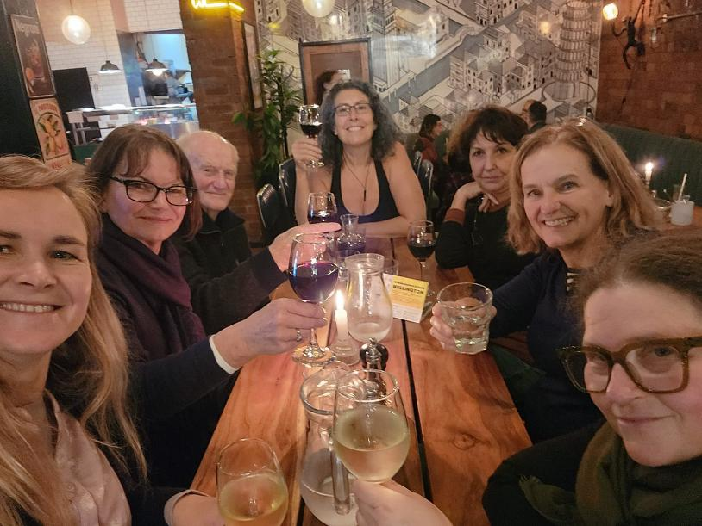

For those of us who were fortunate enough to be able to participate in the entire Mega Famil, or may only have come along for a proportion of the ride, it is in our future tour guiding that the full benefits of the knowledge and experience we have gained on this Famil will become apparent. We cannot wait to begin. Hopefully, in a couple of years’ time, it will be us returning the favour, passing on our knowledge to the next generation of tour guides.

This Famil could not have happened without the generosity of the local guides who have donated their time and expertise and, in some cases, their driving skills. And there was so much driving. Vehicles were generously provided to us by Moa Tours, Maugers and Samuels. The Famil could also not have happened without the generous support of all the local suppliers who have welcomed us in to show us what the tourism industry in Aotearoa has on offer. We cannot wait to come back with paying customers.

---o---

In June, a group of emerging tour guides and others who were eager to expand their knowledge of the New Zealand regions, embarked on a 16-day tour of both Te Waipounamu and Te Ika-a-Māui and. Here is a day-by-day account of what we had the privilege to explore:

Day 1

We started the Famil on a foggy morning in Christchurch. Local guide Andre Booth from Moa Tours took us on a tour of the wider Christchurch area. We learned that the new city's laneways were modelled to the Melbourne setup, and how wood, concrete, steel, strengthened glass, and base isolation technology are used in new post-earthquake buildings.

Our first stop was He Puna Taimoana hot pools. We continued to Christchurch Adventure Park where we went up in the chairlift taking in the stunning vista of the Christchurch region, before heading to Lyttelton.

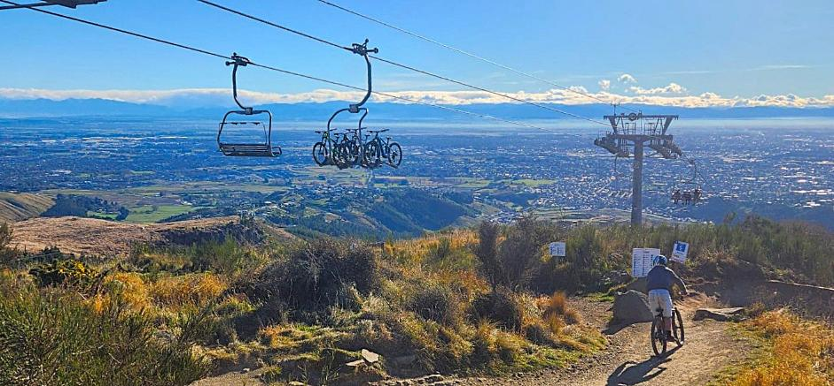

Back in the CBD, we walked with Andre through the Arts Centre with its various galleries, creative spaces, food trucks and booksellers. The quadrant also houses Rutherford’s Den, the place where Ernest Rutherford conducted some of his early experiments.
Our steps then took us along the Avon, along Oxford Terrace, past Kate Sheppard National Memorial, the Christchurch Cathedral rebuild and notable sights along the way.

We ended our tour at Oi Manawa – Canterbury Earthquake National Memorial, a peaceful haven by the Avon inviting us to remember and reflect.

In Christchurch we stayed at the Drifter Hotel, 96 Lichfield Street Christchurch

Day 2

We met Helen Tait, our guide for our drive down to Dunedin on a drizzly day.

We headed towards Geraldine, and we swung by The Tin Shed, a popular stop for tour groups for its extensive offering of merino products.
On our way to Lake Tekapo, we learned about the extensive irrigation channels servicing irrigation systems throughout the Canterbury Plains and Mackenzie Basin.

At Lake Tekapo we stopped at Good Shepherd Church, which is no longer open to the public. We also peeked into the Dark Sky Project Information Centre.

We learned about the history of Twizel as a hub for the workers involved in the Upper Waitaki Hydroelectric Scheme and drove by some of the impressive feats of hydraulic engineering.

In Dunedin we stayed at the Kingsgate Hotel , 10 Smith Street Dunedin

Day 3

On a crisp morning, we started our city tour with local guide Bex Hill, taking in the inner-city sites with special focus on architecture and the early settlers shaping the city. We also explored the Botanical Gardens, a popular stop for tours, and drove through the hilly suburbs. Of course, we attempted to walk up Baldwin Street and drove along Castle Street.

We then headed out onto Otago Peninsula where Bex told us more about the intricacies of the Otago Harbour. We had a very informative guided tour of The OPERA (Otago Peninsula Eco Restoration Alliance) with its penguin rehabilitation centre, where we also ventured out towards the beach and spotted some seals and some nesting penguins.

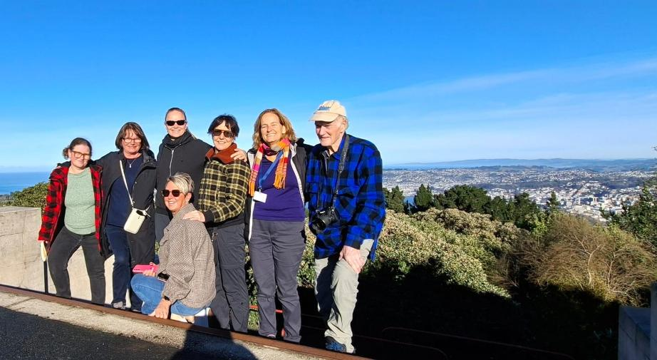

Day 4

For the next leg of our journey, we were accompanied by driver guide Henry Fiala. We followed his stories of the New Zealand gold rush and local wildlife with great interest. We left Dunedin, heading along the Clutha River towards Gore. We enjoyed a brief guided tour at the Croydon Aviation Heritage Centre in Mandeville.

We stopped at Lumsden Railway Precinct for a quick look at the historic trains and a toilet stop. As an aside, one of the useful learnings from this journey was to always know where suitable bathroom stops are located on your route. A rule of thumb we have devised is that a bathroom facility can only score 10/10, if it contains a vase of flowers.

We headed further south into Fiordland. We arrived in Te Anau and were greeted by local guide Martin Silva, who showed us around the Te Anau Bird Sanctuary.

After settling into our hotel, we embarked on our tour of the Te Anau Glow Worm Caves. An absolutely magical experience. A boat took us across the lake, and we were greeted with a hot chocolate and an introductory talk about the glowworms, which are unique to this country. A guide then took us through a narrow entrance over a roaring torrent (it had rained) into the caves. On a tranquil boat ride we took in the night sky mimicking glowworms in all their beauty. We were particularly impressed by the professionalism of the Real NZ staff from the boat crew to the guides.

We stayed at the Kingsgate, 20 Lakefront Drive Te Anau

Day 5

Heading off towards Milford Sound before dawn we stopped at the Mirror Lakes on Milford Road 56km out of Te Anau. A special highlight was our visit to the Eglinton Beech Forest, so beautiful and tranquil, located in the Eglinton Valley a bit further along the road.

The weather came through for us for our Milford Sound cruise with Cruise Milford, and we were treated to some magnificent views of the fiords and waterfalls. We even spotted some dolphins.

Once we concluded our cruise we headed towards Queenstown where we stayed at the
Copthorne Lakefront, Cnr Frankton Rd & Adelaide Street, Queenstown

Day 6

On a sunny morning that turned the surrounding mountains golden we embarked on a walking tour of Queenstown with Henry along the lakefront and the inner city, centering on the history of the town and its historic buildings.

We then headed up in the Skyline gondola to take in the stunning view. Someone from our group was even brave enough to try the new Vortex Slide. Well worth it, apparently.

From Queenstown we headed towards Arrowtown where we were re-united with Helen Tait. We explored the historic township and then headed to the newly opened Ayrburn, a stunning restaurant precinct in a picturesque setting, ideal for groups looking for a luxurious meal.

We had a quick look at AJ Hackett Bungy at Kawarau Bridge. Nobody was keen for a jump, so we headed on towards Wanaka, but not without stopping for a wine tasting at Māori Point Winery in Tarras, a small vineyard founded by two scientists. We sampled a small number of wines, among them the Gold Digger pinot noir and a sparkling rose.
We checked out Wanaka Puzzling World, a New Zealand institution first opened in 1973, where we enjoyed a guided tour by family members of founder Stuart Landsborough.

Our hotel was Wanaka Hotel, 71 Ardmore Street Wanaka

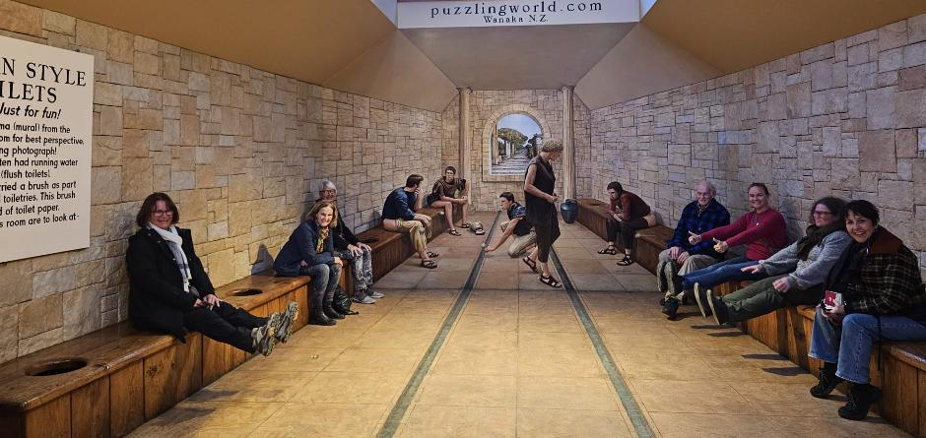

Day 7

Early morning, we were joined by our new driver-guide Chaz Morris and Sharron Hickman, both of whom remained our trusted tour leaders all the way to the ferry in Picton; Chaz making local history come alive and Sharron equipping us for our future as tour guides by dispensing a wealth of practical advice.

We set out towards Haast Pass and Franz-Josef Glacier, stopping at Makarora Country Cafe, a welcoming spot with resident dog, for groups heading towards Haast Pass. If you have a larger group, they would appreciate a heads up a day in advance.

But, alas, our travel plans were foiled: Haast Pass was closed due to flooding. From this situation we learned that it is pivotal to make quick, informed and confident decisions when the path to your next destination is blocked. We rerouted taking the only road available in this adverse weather via Geraldine, Lake Tekapo and Arthur’s Pass, to spend the night in Hokitika instead of Franz Josef.
We learned a lot listening to Chaz’ experience as a veteran farmer, deer wrangler and tour guide. We know a lot about sheep now.
As a special treat to make up for our spoiled travel plans (group morale is also important), we stopped at Mt Cook Alpine Salmon Shop by Lake Pukaki, the famous Fairlie pie shop and the Roger Mahan Heritage Centre in Geraldine, where John Welsh showed us around the collection of historic carriages and construction machinery.

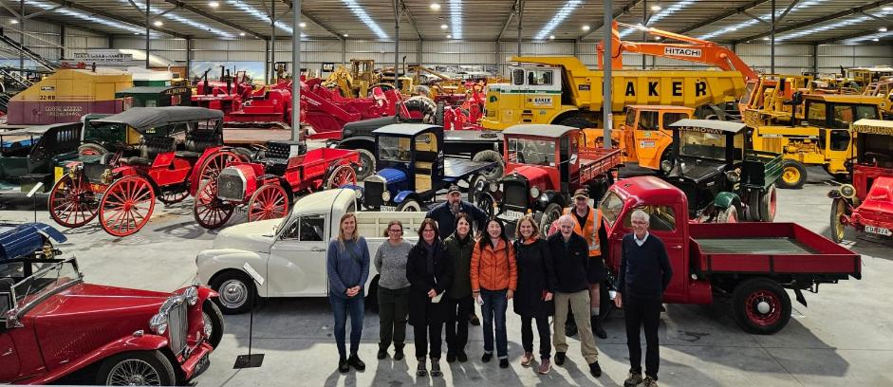

We arrived in Hokitika safe and sound at the tail end of a storm. We were, of course, disappointed that we missed out on Haast Pass and Franz Josef glacier, but the weather here in Aotearoa, as we all know, has a mind of its own.

In Hokitika we stayed at the Beachfront Hotel, 111 Revell Street Hokitika, who amazingly had rooms available for us at short notice.

Day 8

In the morning we enjoyed an informative guided walking tour in Hokitika with local expert Ann Bradley. This also included a quick visit to Hokitika Museum, which is housed in one of the last remaining Carnegie Library buildings in New Zealand. The museum has a mix of historic and modern exhibitions on display.

We met our next local guide, Tine Becker, in Greymouth, where we had a quick tour of the town before heading to Punakaiki. On the drive there Tina entertained us with stories on mythology, even employing puppetry.

At the Punangairi Visitor Centre in Punakaiki we enjoyed the Paparoa Experience, a stunning multimedia telling of the history and traditions of the area, local iwi Ngāti Waewae, the creation of pounamu, and the dramatic tale of Chief Tamaahua.

We said farewell to Tina Becker and headed on to the surprisingly calm Cape Foulwind Seal Colony, where we spotted an abundance of seals.

From there, we headed on to Nelson where we met our next local guide Kirsten Rødsgaard-Mathiesen. We enjoyed dinner consisting of a variety of inventive dishes at Eight Plates, a stunning restaurant in a heritage building in the CBD.

In Nelson we stayed at Rutherford Hotel, 27 Nile Street West Nelson

Day 9

We headed out to Abel Tasman National Park and went onboard for the 10.30 am Vista Cruise by Wilsons Abel Tasman. We stopped at one of the stunning bays along the way, went for a walk and explored the campsite and hut.

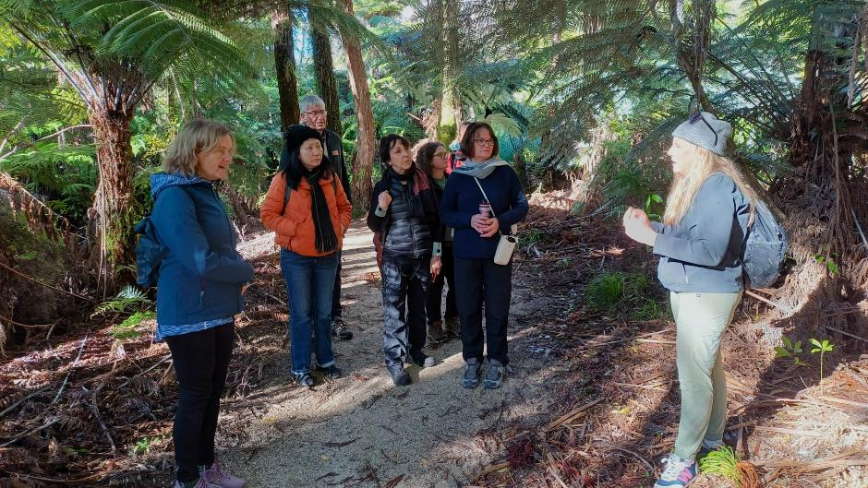

We had lunch at Toad Hall in Motueka, a large cafe with a deli. It was quite busy and booking is recommended.
On our way back into Nelson, we stopped at Pic’s Peanut Butter World on a whim, where, in a stroke of luck, Pic himself was in attendance and was happy to give us a quick tour of the premises.

Back in Nelson, Kirsten led us on a guided tour along historic buildings. We entered the
Suter Art Gallery, a stunning building with a just as stunning collection of art and ceramics. We also explored the nearby Queen’s Garden with the Huangshi Chinese Garden.

In the evening we enjoyed a special visit by German-born jeweller Christine Hafermalz-Wheeler and her husband David who brought along some of her one-of-a-kind creations for us to marvel at.

Day 10

Today it was time to leave behind the South Island and head north.
Before leaving Nelson, we called into the internationally renowned Höglung Art Glass glassblowing studio and gallery, then on our way to Picton at Makana Confections for some artisan chocolate creations
Our last stop in the South was Peter Jackson’s Omaka Aviation Heritage Centre where we enjoyed a quick tour of the impressive exhibition.

A Bluebridge ferry took us across Cook Strait in what must have been one of the smoothest sailings ever.

In Wellington we were greeted by Angela D'Aquaro-Law, who safely drove and guided us all the way across the North Island.

We stayed at the West Plaza Hotel, 110 Wakefield Street Wellington

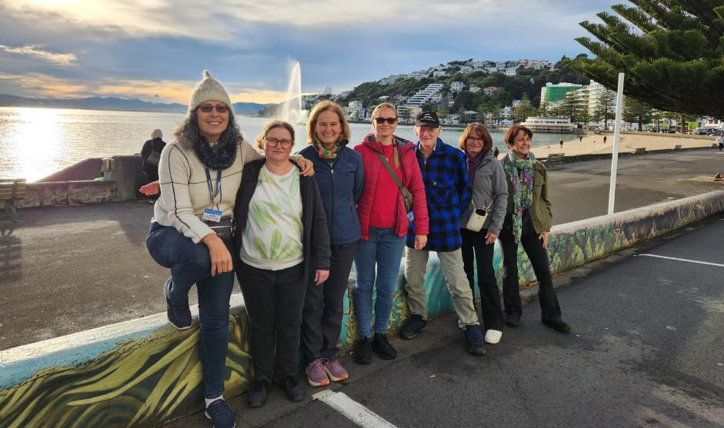

Day 11

We met our local guide Wivian Malmstrom Buckrell and went on a tour of the city, which took us along Marine Parade and up to the Mount Victoria Lookout. Wivian pointed out historic theatres and cinemas along the way.
Back in the CBD we went up in the Wellington Cable Car and took a leisurely stroll down through the botanical gardens. At the bottom of the gardens, we came across a lovely gift shop.

After lunch we walked past the Beehive and government buildings, the brutalist architecture of the National Library and Archives New Zealand buildings to the heritage listed Old St. Paul’s gothic revival cathedral. At Old St. Paul, we took a moment to marvel at the stained-glass window and the wooden nave which is reminiscent of a ship’s hull.
We rounded off the day with a visit to our national museum Te Papa.

Day 12

On this occasion, we were lucky with the weather. While the wind picked up when we left Wellington, it was plain sailing for us. A day later and the weather would have crossed our travel plans again.

We stopped in Foxton to explore the region’s Dutch heritage (and to stock up on liquorice), before continuing to Taihape for lunch, and further on towards Tongariro National Park. The weather was overcast, but we caught a glimpse of Mount Ngauruhoe.

We explored Tongariro National Park Visitor Centre, where hikers pick up maps and information for the Tongariro Crossing and other hikes in the region. While the weather was holding, we got out of the van at Tawhai Falls Walk, which led us down to the location where, in The Hobbit trilogy, Gollum sits on his rock debating with himself and the world.

Then we continued our drive towards Rotorua alongside Lake Taupo.

In Rotorua we stayed at Sudima Hotel, 1000 Eruera Street Rotorua
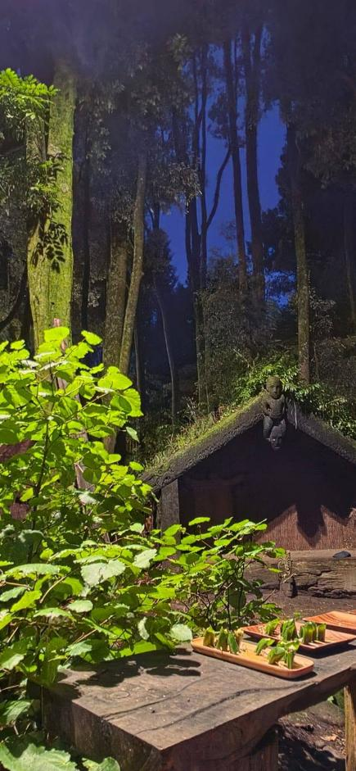
Day 13

In Rotorua, local guide Lu Tyree joined us and we enjoyed a day packed to the brim with Māori culture, local history and wildlife.
First up, we visited Wai-O-Tapu Thermal Wonderland, a stunning landscape of thermal activity, and witnessed the eruption of Lady Knox Geyser, bang on time.
We took in the local sights including the Redwood Forest, and had a stroll through Government Gardens.

We had lunch at Eat Streat, a precinct of small restaurants in the centre of town, suitable as a lunch stop for groups.

After lunch we headed to the National Kiwi Hatchery, where we learned about the life cycle of a kiwi, its natural predators, and that the birds prefer a solitary lifestyle. The visit was very informative and the guide engaging.
Next, we went to Te Puia for a guided tour of the geothermal grounds, the NZ Māori Arts & Crafts Institute, where we could see the carvers and weavers at work, as well as the Kiwi Conservation Centre.

For dinner we were in for a special treat. We had the privilege and pleasure to experience the Winter Matariki programme at Te Pā Tū. From the time we arrived for this immersive experience, we were in awe of the professionalism, warmth and the talent of the performers. We felt welcome and looked after. The food was delicious and plentiful, the performances powerful and beautiful.

Day 14

We left Rotorua behind and headed to Waitomo. On the way we quickly stopped by Hobbiton, which has not lost any of its pulling power. It was packed.

At Waitomo Caves we took a tour that led us down to the cathedral, where one of our group treated us to a song making the most of the amazing acoustics. We then proceeded to the glowworm grotto, where we glided on the dark waters under a sky of glowworms. Due to the heavy rain of the previous day, we could not disembark at the cave’s exit. The water level was too high. We returned to the jetty instead and walked back out of the caves.

We stopped for a late lunch at the Homestead Cafe, which is easily spotted by the giant apple outside. The cafe is big enough for groups.
Then we proceeded with our drive to Auckland.

In Auckland we stayed at Auckland City Hotel, 157 Hobson Street Auckland

Day 15

We began our day with a walk around downtown Auckland. We were led by David Hill from Auckland Walks. David is very knowledgeable on the history of downtown from before the land reclamations to the present day. We especially appreciated his expertise in architecture and the arts. His business partner Terry Hobin also accompanied us on the walk. Auckland Walks offers a variety of walking tours in central Auckland.

We then went for a drive with Angela through the wider downtown area, Wynyard Quarter, Mission Bay, Bastion Point and Parnell before heading to Arataki Visitor Centre, the gateway to the Waitakere. The visitor centre holds a wealth of information about the region. There is even a short film that plays on a loop.

We headed back into the city to visit the All Blacks Experience which was quite interactive and well done. We learned some interesting facts about the All Blacks, including the origin of their name. This concluded our Auckland day.

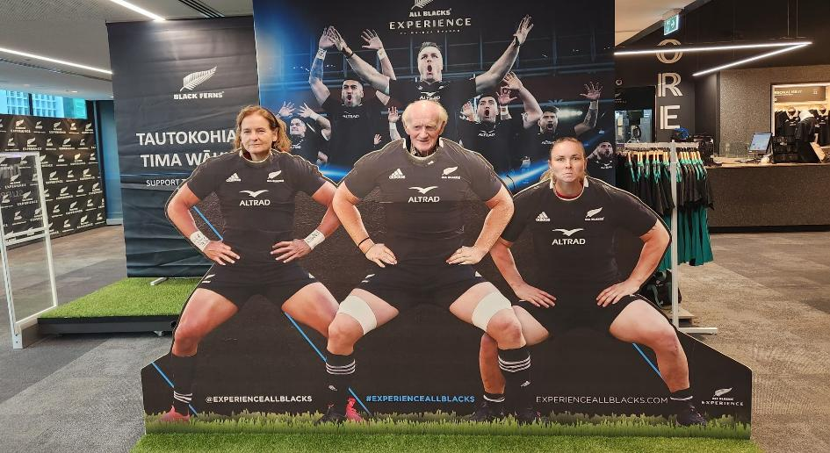

Day 16

On our last day we headed north, through Warkworth and the Brynderwyns. Angela told us stories of Māori mythology. After a quick stop at Kawakawa for a bite to eat and the obligatory photo of the Hundertwasser toilets, we headed to Waitangi.

At the Waitangi Treaty Grounds, we joined a guided tour across the grounds explaining the history of Te Tiriti o Waitangi, the founding document of Aotearoa, and the significance of the waka displayed on the grounds. After the conclusion of our tour, we had limited time to explore the museum.

On our way back south we stopped by the Hundertwasser Art Centre in Whangarei. We did not enter the exhibition spaces, but with its quirky design, it looks well worth a visit. The museum is right by a quaint shopping precinct with cafes and plenty of parking.
On the way back down to Auckland we had a quick explore of the grounds of Warkworth Museum and stretched our legs at the adjacent Parry Kauri Park to view the large kauri tree.

After arriving back in Auckland, we said our farewells. Some of us hope to reunite at the ProGuides AGM in Oamaru in September.

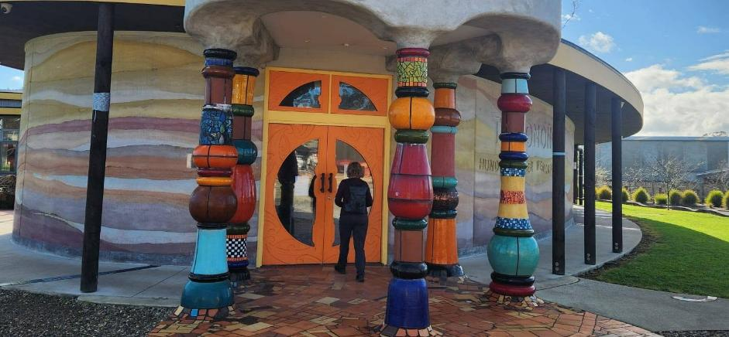

---o---

Best attempts have been made to include all the highlights, generous people and suppliers by name that have made this inaugural Mega Famil such a magnificent, educational and rewarding experience. Any accidental omissions will be my fault alone. It has been a whirlwind.

By Melanie Wittwer

